**“Designing and Building an Autonomous Robot System Prototype”**

**Computer Science & Engineering**

**University of Rajshahi**



**Submitted By**

**Md. Nazmul Hasan**

**ID:2111176131**

**Session:2020-21**

**Project Advisor**

**Prof. Dr. Bimal Kumar Pramanik**

**“Designing and Building an Autonomous Robot System Prototype”**

**Contents of this Project’s**

**Abstract** 2

Introduction 3

General Description 3

**Literature Survey** 3

Methodology 4

System Architecture 5

**Improvement of projected system over existing system.** 6

**Time Schedule:** 6

**Project Cost :** 7

**Conclusion** 7

References 7

# **Abstract**

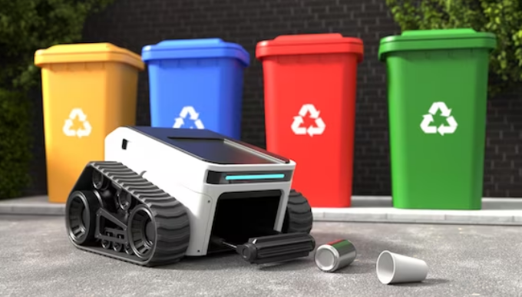Now-a-days, management of waste from its collection to dumping and disruption has become one of the greatest challenging and arduous chore for municipal corporations, all around the globe. To make this tedious job facile, a new concept of Smart Dustbin has been taken into consideration for Smart buildings, hospitals, schools and railway stations. The Smart garbage collector thought is an advancement of traditional garbage collector by levitating it to become smart inculcating sensors and some form of logics. This smart collector is a revolutionary idea of application of line following garbage car and pole fixed garbage part on predesigned locomotive path. The fixed bin makes use of ultrasonic sensors or level of garbage detection and updates the coeval level of the bin to the garbage car, using RF Module. This is thereby a fully automated system, making small contribution towards the theme of CLEAN RAJSHAHI GREEN RAJSHAHI.

**Fig 1.** Garbage Collector

# **Introduction**

## **General Description**

In today's era as we know that where countries are developing at a rapid rate a lot of unwanted waste is being generated like electronics, plastics and many biodegradable products. Waste management being the utmost spurned factors in developing countries creates an urgency to address this problem. In metropolitan or city areas, the clearance of waste management has been a grind task for the majority of the country all over the world. There is need of a well- organized waste clearance system is mandatory by keeping green environment. There are many existing expertise mechanism are available for handling as well as managing waste. But the lacking for gathering information is a major challenging task. This flounder will perturb the quick nationwide rate of growth in heaped urban areas as well as its growing demand for the citywide ecological and environmental protection. This is a major challenging in waste management system to create a prototype because of the paucity of planning and systematization among government, people and local authority for shipping and processing waste. Currently the waste gathering is conventional which acquire a lot of labours and is time overwhelming process.

The Smart garbage collection bin also works in the same way with the amalgamation of sensors including ultrasonic sensor and IR sensor that predicts and gives a signal for its garbage level and determines the absolute path respectively. The main cynosure of this research is to design a highly cost effective and utilitarian waste management system which shall make regulation and picking up of the garbage as easy and convenient as possible. In the following sections, the methodology of the system will be elaborated along with the description of the hardware used. The design of the system, the algorithm, and the flowchart will follow the hardware description.

## **Literature Survey**

A number of different research papers have been surveyed to gather the related information regarding the project. A Smart Dustbin was presented [1], based on IoT that contained the smart bin which was being made on a platform, based on Arduino Uno board that had been linked with ultrasonic sensor and a GSM modem. Some researchers also made a conclusion that numerous issues like durability, perpetuation and affordability were seen during the designing of these bins [2]. The scientists [3] also suggested the technique for management and disposal of garbage, in which the garbage bin had been made to interface and connect with a system which was based on microcontroller and also had IR systems along with a main system that clearly displayed the current weight and level of the waste in the bin. In other systems the present status of dustbin was made to see on a web page that was mobile based, by using the Wi-Fi [4]. The author also suggested a way for managing the picking up of garbage from different location of the cities and common living area [5]. In this system, the amount of trash in the dustbin was sensed by the ultrasonic sensor that will thereby report the present situation of the trash bin to recommended authority via GSM module. Some systems also developed a GUI that was MATLAB based [6-9]. Some researchers also analysed Decision System that may also be worned by trash collection in the urban regions [10-14]. This system was made to handle the impotent collection of waste in the city areas that are too inaccessible. Some of them placed a camera in those areas of the urban regions that were facing severe problems. [15-18]. A number of bins had been placed throughout the city that were governed by an embedded device, low in cost and which helped a lot in estimating about the fill level of waste in the dustbins. [19]. A unique ID had been given to each bin so as to detect and analyse that which among the all bins has been filled and is ready to be dumped or emptied. This was predominantly categorized into two areas: one that is the transmitter section and the rest one was the section of the receiver [20]. The first area was composed of a sensors and microcontroller that will keep track of the level of waste and sends the concerned information onto the control room, with the use of the RF Transmitter, after that the RF Receiver collects and receives the sent information and again moves it to the concerned person, to make the bin devoid as fast as it can [21-23]. The mobile software application has been designed [26] to indulge people in the task of collecting and dumping the solid and other types of waste. A number of detailed ways associated to the view from persons about the current situation of the area with allusion to hygiene and cleanliness, classes of taking shots and then uploading it to computer server application, are being given that will make the computer applications far more useful and helpful so as to earnestly dower in a course of waste management [27].

# Methodology

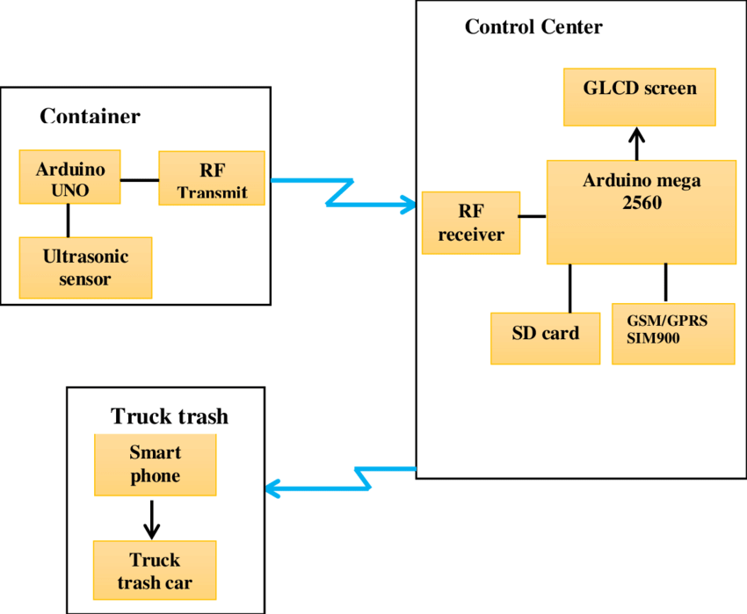In “Smart Garbage Collecting Robot and Monitoring System” the height of the trash filled in the fixed part bin is identified using an Ultrasonic sensor, and thus the level is remitted to the garbage car part with the help of RF Module. Microcontroller is mainly used so as to interface the ultrasonic sensor with the RF module. This is a fully automated system in which the garbage car moves automatically when it gets a signal via RF Module from the Garbage bin, when it gets completely filled. This will help to manage the garbage collection efficiently. Here in this system, Infrared (IR) sensor is used for garbage level detection on garbage car. The IR sensor emits light that is unseeable to the eye of humans because it pertains infrared wavelengths, which can be recognized by the electric equipments. RF Module is used for conveyance purpose; so as to transmit that the concerned collector is full and also it helps in managing and controlling the garbage panel motor of the trash bin that is fixed. Arduino board is used to interface the ultrasonic sensor, motor and RF module. The IR sensor arrangement acts as level detector and controlling garbage car. The IR sensor and cars motor interface with Arduino. The program is burned in the microcontroller Arduino Nano ATmega 328p using the Arduino software (IDE). These Data or information of the muck heights of corresponding dustbins sent to moving car part for empty the bin as fast as it can. Then the garbage car moves toward the collecting garbage in the predefined path and after dumping back to track to reach start point.

**Fig 2.** Block Diagram of Garbage Collector

## **System Architecture**

**1. Arduino Nano (Atmega 328P)**

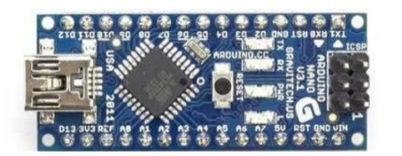The Atmel 8 bit microcontroller merges 32KB flash memory with the capabilities of read-while-write, 2 KB SRAM, the 32 general purpose working registers, three pliable counters/timer, external and internal interrupts, a SPI serial port, 6-channel A/D converter, programmable watchdog timer as well as the five software power saving modes.

**Fig 3. Shows Arduino Nano Atmega 328P**

**2. Ultrasonic Sensor(HC-SR04)**

Fig shows the ultrasonic sensor. This sensor is being placed in the fixed pole part of garbage bin, so as to intimate about the garbage level of the fixed garbage part.

**Fig 4. Shows ultrasonic ranging sensor**

**3. Infrared Sensor**

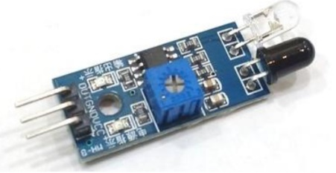Infrared sensor here used is to control the path of garbage collector robot. It is also used to encounter the extent of the muck in the garbage car. Fig shows the diagram of infrared sensor.

**Fig 5. Shows infrared sensor**

**4. RF Module (433MHz)**

RF Module is basically used for conveyance purpose over ranges, mainly to indicate the garbage car about the level of the fixed dustbin. If the dustbin is completely filled it will send a signal to the garbage car part, and the garbage car will come and empty the dustbin instantly.

**Fig 6. Shows the RF Module for transmission purpose**.

## **Improvement of projected system over existing system.**

• Real-time info on the extent of the trash in dustbin.

• Saves environment and money.

• Ensures that the dustbin is empty and not overflowing with garbage.

• Saves life of workers from any type of harmful or infected objects in the garbage.

• Intelligent management of the services in the various areas.

• Effective usage of dustbins.

• Waste management can be done in a faster and in a smarter manner.

# **Time Schedule:**

# **Project Cost :**

# **Conclusion**

This project is devised to render the task of muck collection from differing places and then dump it at a particular location from where the muck is conveniently taken for the action of reusing and recycling. By intimating the notification of level of garbage filled in the fixed dustbin to the garbage car, we can decrease the number of trips of the garbage collecting vehicle, thus saving power and money. Also by introducing the RF Module on the fixed dustbin part, we are making this system fully automated. Thus, by implementing this project in real time scenarios we can make a contribution towards the enhancement of Smart City Project, thereby making the dream of CLEAN RAJSHAHI GREEN RAJSHAHI come true.

# References

[1]. Mrs. Sudha Rajesh, Ms. R. Aishwarya, Ms. R.Bhakya Lakshmi, “Garbage monitoring and management using internet of things”,

International Research Journal of Engineering & Technology, 2018.

[2]. Maya Chavan, T.R. Pattanshetti, “Survey on Municipal Waste Collection Management in Smart city”, in International Research

Journal of Engineering & Technology, 2018.

[3]. S. Vinoth Kumar, T. Senthil Kumaran, A. Krishna Kumar , “Smart Garbage Monitoring and Clearance System using Internet of

Things”, in IEEE International Conference on Smart Technologies & Management, August 2017.

[4]. Pallavi K N, Dr Ravi Kumar V, “Smart Waste Management using Internet of Things: A Survey, in IEEE International conference

on I-SMAC, 2017.

[5]. Pranjal Lokhande, M.D.Pawar, “Garbage Collection Management System”, in International Journal of Engineering and Computer

Science, 2016.

[6]. Monika K A, Rao N, Prapulla S B and Shobha G, “Smart Dustbin-An Efficient Garbage Monitoring System” in International

Journal of Engineering Science and Computing, 7113-16, 2016.

[7]. Navghane S S, Killedar M S and Rohokale D V, “ IoT Based Smart Garbage and Waste Collection Bin”, in International Journal of

Advanced Research in Electronics and Communication Engineering (IJARECE), 1576-78, ,2016 .

[8]. Automatic Garbage Maintenance System. International Journal of Engineering Research in Computer Science and Engineering

(IJERCSE). Vol 3, Issue 9, September 2016.

[9]. Dr.N.Sathish Kumar, B.Vijaylakshmi, R. Jenifer Prathana, A. Shankar, “IOT Based Smart Garbage alert system using Arduino

UNO”, IEEE Transactions on sensors, 2016.

[10]. Kasliwal Manasi H and Suryawanshi Smithkumar B, “ A Novel approach to Garbage Management Using Internet of Things for

smart cities”, in International Journal of Current Trends in Engineering & Research, 348-53, 2016.

[11]. Gaikwad Prajakta1, Jadhav Kalyani, Machale Snehal , “Smart garbage collection system in residential area”, in International

Journal of Research in Engineering and Technology , 2015.

[12]. Vikrant Bhor, Pankaj Morajkar, Maheshwar Gurav, Dishant Pandya4 “Smart Garbage Management System” International Journalof Engineering Research & Technology (IJERT) ISSN: 2278-0181 IJERTV4IS031175 Vol. 4 Issue 03, March-2015.

[13]. GaikwadPrajakta, JadhavKalyani, MachaleSnehal, “Smart Garbage Collection System in Residential Area” in International Journal

of Research in Engineering and Technology, March 2015.

[14]. Kanchan Mahajan, Prof.J.S.Chitode, “Waste Bin Monitoring System Using Integrated Technologies” in International Journal of

Innovative Research in Science, Engineering and Technology, July 2014.

[15]. J. Jin, J. Gubbi, S. Marusic, and M. Palaniswami, “An information framework for creating a smart city through internet of things,”

IEEE Internet of Things Journal, vol. 1, no. 2, pp. 112–121, 2014.